A000-AM,C-Taino-Cemi- Maquetaurie Guava-Lord of the Dead-Rhyolite-1000 CE

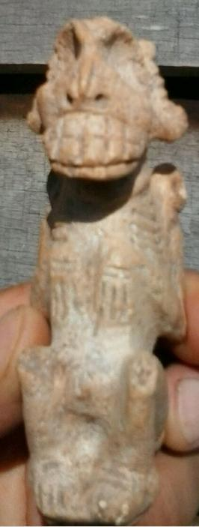 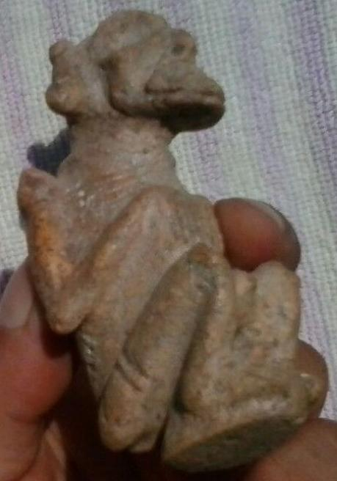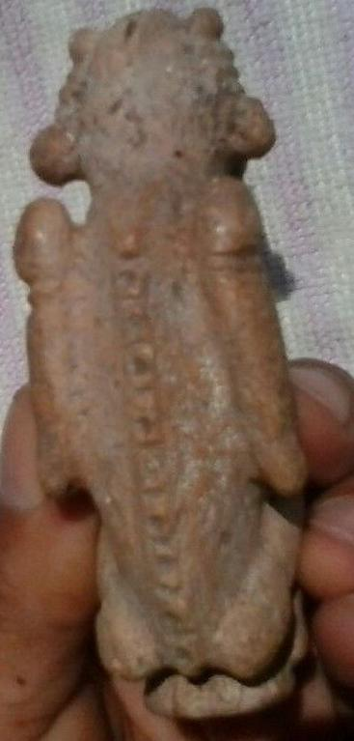

Figs. 1-3. AM,C-Taino-Cemi- Maquetaurie Guava-Lord of the Dead-Rhyolite-1000 CE

Case No.: 18

**Accession No.**

**Formal Label:** AM,C-Taino-Cemi- Maquetaurie Guava-Lord of the Dead-Rhyolite-1000 CE

**Display Description:**

The Tainos believed that the dead went to Coaybay ( "abode of the absent") at the end of an island called Soraya. A place in the distance, inaccessible to the living, governed by [Maquetaurie Guava](https://translate.googleusercontent.com/translate_c?depth=1&hl=en&prev=search&rurl=translate.google.com&sl=es&u=http://pueblosoriginarios.com/centro/antillas/taino/maque.html&usg=ALkJrhjPHXvKfHZkwRcHGDMcxmwHjzZ-Zw) ; It is an independent space with an independent leader. Opias (or hupias ) - spirits of the dead, who like Opiyelguobirán are irreverent and mocking - enjoy cheating the living.They sleep during the day and go out at night to eat guava, whose juice produces a black paint with which they symbolized death.

Maquetaurie Guava’s function was to maintain the balance between the antagonistic forces of the day (order, world of the living) and night (disorder, world of the dead).

The lord of the dead

"Dog fasting, abstinence guava". He is the lord of Coaybay - "Abode of the absent" in the region of Soraya-, responsible for manter guard and watch the rest of the space where absent.

The opy (or hupías)-spirits of the dead, which like Opiyel Guobirán are irreverent and mocking, they enjoy deceive living. They sleep during the day and come out at night to eat guava juice which produces a black paint with which symbolize death.

Its function was to maintain the balance between the opposing forces of the day (order of the living) and night (disorder, world of the dead).

So says [Ramon Pane](https://translate.googleusercontent.com/translate_c?depth=1&hl=en&prev=search&rurl=translate.google.com&sl=es&u=http://pueblosoriginarios.com/biografias/pane.html&usg=ALkJrhj93Q1oq79G5oFuYQsZQlAOSsmzgA) , in Chapters 12 and 13 ["Relation about the antiques of the Indians"](https://translate.googleusercontent.com/translate_c?depth=1&hl=en&prev=search&rurl=translate.google.com&sl=es&u=http://pueblosoriginarios.com/textos/pane/3.html&usg=ALkJrhhndrqPsArDfEL5jUZ4n7MdKrmFUA) (after http://pueblosoriginarios.com/centro/antillas/taino/maque.html):

Chapter 12:

"They think there is a place to go dead, called Coaibai, which is at one end of the island, called Soraya. The first one was in the Coaibai say it was one called Maquetaurie Guava, who was lord of Coaibai, room house and the dead. "

Chapter 13:

"They say that during the day the dead are held;. At night will break and eat some fruit called guabaza, flavored with ... that day are ... [locked] At night, they become in fruit, they have their playground, and they together with the living for the dead are as follows:. that hand will touch the belly, and if they find the navel say it is operito, meaning dead, they say that the dead have no navel, and so is sometimes deceiving, because there noticing this, lie with a woman of the Coaibai, and when they think hug, they have nothing, because suddenly disappears this is what they think today. . about this long as a person Goeiz call the soul lives, and after the call opia dead, the Goeiz say it often appears, and as a man or as a woman, and say there has been man who dared to fight a Goeiz, and wanting to embrace it, it disappeared and Indian arms got away, over some trees, which was hung. This I believe everyone in general, as small than their elders, and they are dead appear as father, mother, brothers, relatives, or other forms. The fruit of that claim eating the dead, is the size of a peach. The dead are not displayed by day, but always at night, and therefore, not without great fear some Indian dares to go alone at night. "

**LC Classification: F1909**

**Date or Time Horizon: 1000 CE**

**Geographical Area: Caribbean**

**Map:**

**GPS coordinates:**

**Cultural Affiliation:**

**Media:**

**Dimensions:**

**Weight:**

**Condition:**

**Provenance:**

**Discussion:**

**References:**